The Big Drip

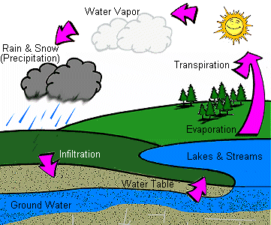
Groundwater is water that comes from the ground. Sounds easy, doesn't it? Amazingly, many people use groundwater but don't even know it. Groundwater comes from rain, snow, sleet, and hail that soaks into the ground. The water moves down into the ground because of gravity, passing between particles of soil, sand, gravel, or rock until it reaches a depth where the ground is filled, or saturated, with water. The area that is filled with water is called the saturated zone and the top of this zone is called the water table. Makes sense, doesn't it? The top of the water is a table! The water table may be very near the ground's surface or it may be hundreds of feet below. The water that does not saturate the ground and settles above the earth is called surface water. Surface water is water collecting on the ground or in a stream, river, lake, wetland, or ocean; it is related to water collecting as groundwater or atmospheric water.
A watershed is an area of land that catches rain and snow and drains or seeps into a marsh, stream, river, late, wells, or groundwater. You are probably sitting in a watershed right now.

Purpose: To show how water moves in a watershed and to how surface water is formed on the surface of the Earth.

Materials: Paper Plate Small cup with water
Dropper 2 markers (of different colors)
Piece of white paper Paper Towels

Procedures:
1. Take the sheet of paper and crumple it. Next, partially smooth it out, leaving some ridges. Lay the paper on the plate like a mountain range.

2. Select one color marker and color the ridges/points of the HIGH creases. You are marking the high points on the paper.

3. Use the other color to color the low places on the paper. You are marking the low points on the paper closest to the paper plate.

Answer the PREDICT QUESTIONS on your notebook paper.

Predict Questions: Answer in complete sentences and thoughts.
- What will happen when you drop water onto your model?
- Will all the water flow south? Why or why not?

4. Use the dropper to collect water from the cup. Start by dropping 15 drops across the paper (the marker will run). Make sure you drop the water all over your paper model. Make additional drops if the water is not flowing on your paper. Stop

Now, answer the CONCLUSION QUESTIONS on your notebook paper.

Conclusion Questions: Answer in complete sentences and thoughts.
- Describe what happened in your model as you dropped water on your high and low creases?
- How is this lab demonstrating an example of watersheds?
- How might land forms change over a period of time if the water flowed in the same direction down the mountains each time it rained?
- What are some things that might cause water to change course during a rain storm?
- How does the population in your community affect the distribution of water?
- What would happen to a watershed if there was a drought?
- Describe groundwater, surface water and saturated zone.
- Draw and label the water cycle diagram found on page one of this lab.
- What does the paper used in this exercise represent?
- Can you explain the events of the spray and the representation of this experiment?
- Why does water flow down into the creases?
- Where does this water go in the end? Why?
- What do you think this represents?
- In the landscape what’s the name for the water that runs along the bottom of the “creases”?
- What happened to the ink as the water flowed? Where did it end up?
- How is this a problem or concern?
- Consider how this is similar to and/or different from the Barnegat watershed? Where in our watershed would most of the pollutants end up?
- Groundwater was missing from this model. What might be different about the effects it has on the Bay?
- Why is it important to make sure not to use chemicals that can pollute the Bay even if your house is miles away from the Bay itself?
5. Carefully take your plate to the trash and dispose of your sample watershed. Don’t throw the plate away! Clean up your lab materials and return them to the box.

