**Candy Bar Earth**

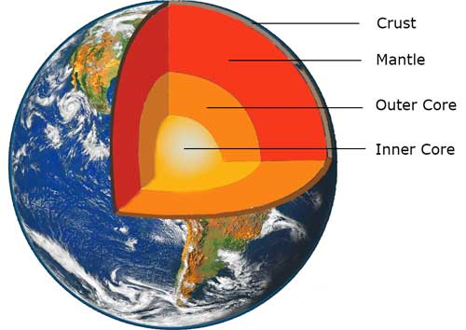Materials:

**Layers Of The Earth Activity:**

2 Milky Ways (regular or mini)

1 Plastic knife

1 Paper napkin

**Plate Tectonic Activity:**

½ a Graham cracker

Vanilla Icing

Plastic knife

1 square of Wax paper

Today we will learn about geology and the composition of the Earth. What does “Geology” mean?. “Geo” means “earth” and “ology” means “to study”. This activity helps us study the earth by learning what it is made of and how it can be changed. We will learn about the four layers that make up the planet Earth (Crust, Mantle, Inner and Outer Core).

**“Layers of the Earth” Activity**

1. Place a Milky Way candy bar on a paper napkin.

2. Cut down the middle of the candy bar.

* The chocolate on the top of the candy bar represents the crust of the Earth. This is the thinnest, most brittle layer. It is made up of soil and rocks. The land we walk on and the land under the oceans are part of the crust.
* The caramel layer represents the mantle. It is made up of hot molten rock. This molten rock is what erupts from volcanoes in the crust.
* Notice the light brown layer and tell them it represents the outer core. It is made up of liquid iron.
* The bottom layer of chocolate is the inner core of the Earth. This layer is made of solid iron and is the hottest part of the Earth. The temperature of the inner core is almost as hot as the sun.

3. Now that you’ve visualized the layers of the earth, grab a new milky way to simulate how the layers respond to change! We will look at how the Earth’s layers change as a result of plate tectonics**. Plates are large sections of the Earth’s crust that slowly move over partially melted rock in the upper mantle.** This movement explains how the Earth’s surface has changed over time and predicts how it will change in the future. This theory is called plate tectonics. It helps to explain the formation, movements, collusions, and destruction of the Earth’s crust.

* Pull the milky way bar apart slowly. This is simulating what’s called a “divergent plate boundary”, in which the two tectonic plates move away from one another. What do you think will happen to the land as a result of a divergent plate boundary? Draw what you see below:
* Now, Push the two halves of the candy bar together, slowly and forcefully. This is simulating what is called a “convergent plate boundary”, when the two plates converge or “collide” together. Convergent boundaries are responsible for creating mountain ranges! Draw what you see below:

**“Plate Tectonics” Extension Activity**

1. Spread frosting on wax paper to cover an area a bit larger than the graham cracker square.

2. Break the graham cracker on its seam to make 2 rectangles and place the 2 rectangles, touching, on top of the frosting. Note: The graham crackers represent the Earth’s crust, which is broken up into plates. The frosting represents the mantle.

3. Move the plates (crackers) apart to expose some of the mantle (frosting). This is called a spreading zone. When plates move apart, it creates cracks in the Earth called rift valley. Pulling apart of the plates allows hot, melted rock to come up through the crack in the earth. This is how a volcano’s opening is formed.

4. Push the plates together until the middle forms a ridge. When plates collide they create mountains. This is called a collision zone. An example is the Appalachian Mountains, which were formed when Africa collided with North America during formation of Pangea.

5. Slide the edges of the crackers against each other. The horizontal grinding and sliding of the plates causes earthquakes. This is called a shearing fault. A fault is a fracture in the earth’s crust. An example is the New Madrid Fault, which runs along the eastern border of Missouri. Earthquakes can, and have, occurred along this fault line.